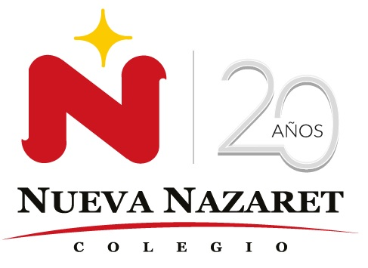
Nuestra misión: “ Formar hombres y mujeres Cristianos , Nobles y Capaces ”

Curso: QUINTO BASICO
Asignatura: Inglés

Clase: 3 Oral Reading
Instructivo:
- Leer texto y practicar pronunciación. (ya trabajada con antelación en clases)
- Enviar audio y/o video con la grabación del texto para su evaluación, al e-mail hruiz@colegionuevanazaret.cl Indicando nombre del alumno y curso.
- Fecha de entrega: 08 de abril 2020
- Criterios de evaluación: fluidez, volumen y pronunciación.

Contenido:
I AM JENNIFER

Hi! I’m Jennifer! I am 9 years old. I live in Houston, Texas with my mother, father, and two brothers.

I like going to school but I hate doing homework and taking exams. At school I study English, Spanish, Science, Social Studies and Mathematics.

I love going to school and seeing my friends and teachers every day.

I also like to play baseball after school. I don’t have any sisters but my best friend, Olga, is just like my sister.
We tell each other everything. We also study and watch TV together.

When I grow up I’m going to be a nurse and take care of sick people.

