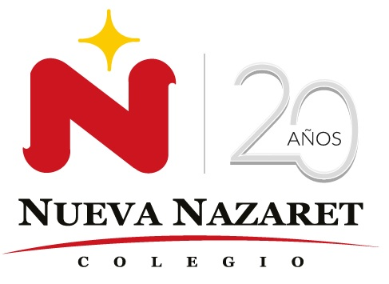
Nuestra misión: “ Formar hombres y mujeres Cristianos , Nobles y Capaces ”

Curso: QUINTO BASICO
Asignatura: Inglés

Clase: 3 Family Members
Instructivo:
- Leer el contenido. Miembros de la familia. Observar árbol familiar y parentescos.
- Desarrollar actividades asignadas en contenido. Entregar el día 04 de abril, hasta 22:00 hrs.
- Enviar la actividad finalizada al correo hruiz@colegionuevanazaret.cl. Si no puedes imprimir, desarrolla la tarea en tu cuaderno. Tómale una foto y envíala al email indicado.

Contenido:
Family Members
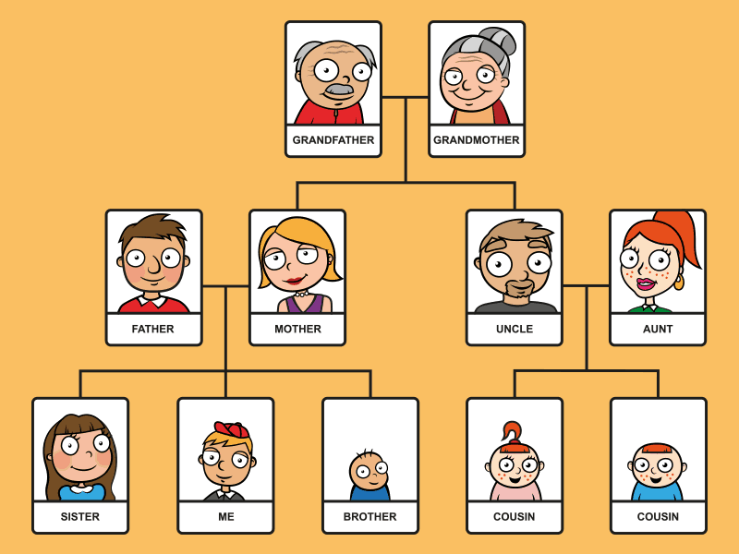

- Find in a dicctionary and write the meaning in Spanish.

Nephew: __________________
Parent: _________________
Wife: ___________________
Husband: ______________
Baby: ___________________
Son: ___________________
Niece: ___________________
Daughter: _______________
- Classiffy this words in MALE – FEMALE – BOTH

Mother- father – grandparent – wife – baby – sister – niece – uncle – aunt – cousin – brother – child – son - grandfather

Male | Female | Both (can be male or female)

- Write the correct family members.

- Your mother and father are also called your __P__________________ .
- Your brother or sister’s son is your _________________ .
- Your aunt and uncle’s children are your ___________________ .
- Your mother or father’s mother is your _________________ .
- A brother________ and ___________ both have the same parents.
- When a couple gets married the man is the ____________ and the woman is his ________.

- Draw o paste a photo about your family members and complete with information.
Example:
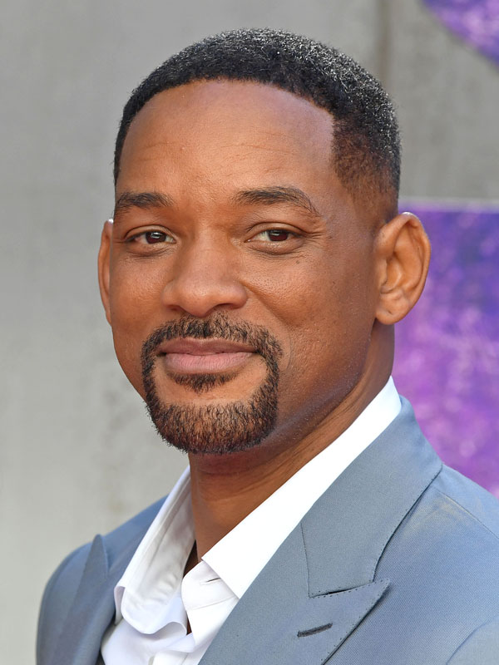
My father’s name is Will. He is an actor. He is 51 years old.

