
Nuestra misión: “ Formar hombres y mujeres Cristianos , Nobles y Capaces ”

Curso: Séptimo Básico

Asignatura: Inglés

Clase: 2 Expressing Likes and Dislikes

Instructivo:
- Observa 2 videos introductorios sobre las preferencias: likes and dislikes
- https://www.youtube.com/watch?v=vf_Z1zqrSgk
- https://www.youtube.com/watch?v=yWRogEqTBIA
- Desarrolla las actividades que aparecen en “contenido”
- Envía una foto/ imagen de las actividades finalizadas al e-mail hruiz@colegionuevanazaret.cl Indicando nombre del alumno y curso.
- Fecha de entrega: 08 de abril de 2020 hasta las 22:00 horas.

Contenido:
Expressing Likes and Dislikes

- Read the sentences below.

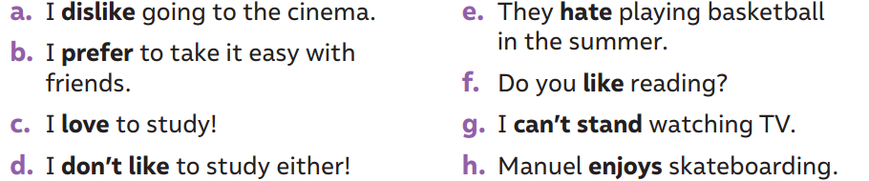

- Classify the sentences in Likes and Dislikes. Write them.

EXPRESSING LIKES  | EXPRESSING DISLIKES 
- Do you like reading?  - ________________________________  - ________________________________  - ________________________________  - ________________________________ | - They hate playing basketball in the summer.  - ___________________________________  - ___________________________________  - ___________________________________  - ___________________________________

- Write 2 sentences expressing likes and 2 sentences expressing dislikes.

- ______________________________________________________________________
- ______________________________________________________________________

- ______________________________________________________________________
- ______________________________________________________________________

- Look at the pictures and write the correct feeling/emotion.

Happy – sad – angry- tired – excited – thirsty – hungry – scared –bored

 |  | 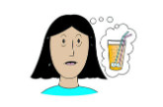
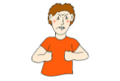 | 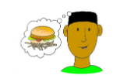 | 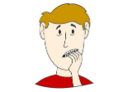
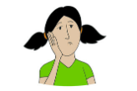 |  | 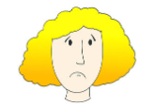

- Write 5 sentences using the words from exercise 4.
- ________________________________________________________________________________
- ________________________________________________________________________________
- ________________________________________________________________________________
- ________________________________________________________________________________
- ________________________________________________________________________________

