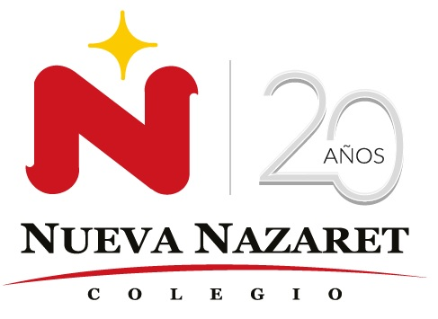
Nuestra misión: “ Formar hombres y mujeres Cristianos , Nobles y Capaces ”

Curso: Séptimo Básico
Asignatura: Inglés

Clase: 4 Healthy food and junk food
Instructivo:
- Ingresa a google classroom con el código opyrwsq Desde google classroom también puedes aclarar dudas directamente con el profesor.
- Primero, escucha con atención el audio adjunto sobre una conversación, las veces que sea necesario.
- Segundo observa el power point sobre Expressing agreement and disagreement.
- Desarrolla las actividades asignadas en contenido. Usando el audio y el power point si lo necesitas.
- La guía puedes imprimirla o desarrollarla en tu cuaderno de inglés.
- Luego, envía una foto/ imagen clara de las actividades finalizadas al e-mail hruiz@colegionuevanazaret.cl Indicando nombre del alumno y curso.
- Fecha de entrega: 25 de mayo de 2020 hasta las 22:00 horas.

Contenido: ACTIVITIES


1. Look at the pictures and answer the questions.

a. What do you think the conversation is about?
____________________________________________
b. Do you think the food we eat is important for our health?
_______________________________________________

2. Listen to the audio and circle true or false.

- The doctor told Ben that he is not eating enough fruit. True/False
- Ben doesn’t eat junk food regulary. True/False
- Ben doesn’t like sweet food very much. True/False
- When Ben is feeling thirsty, he drinks soda. True/False
- The doctor thinks that Ben eats healthy. True/False

3. Listen again and look at the pictures below. Circle the food and drinks mentioned in the conversation.

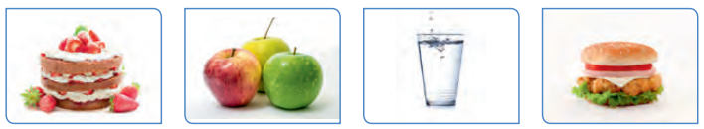

3. Answer the questions about you.

- What is your favorite healthy food? __________________________________________
- What are some healthy food that you eat at home? _____________________________
- Mention 2 junk food ______________________________________________________
- Translate into Spanish this expressions.
a. Uh, no, not really. ___________________________________
b. No, it isn’t. ________________________________________
c. Oh yes, completely. _________________________________
d. Yes, that’s right._____________________________________
e. Of course!__________________________________________
f. Hmm, I’m not sure.___________________________________
g. Absolutely not!______________________________________
h. Well, yes, but it’s not only_____________________________
- Read the sentences about healthy and unhealthy foods below and agree or disagree with them, using expressions like this:
Uh, no, not really. / No, it isn’t. / Oh yes, completely. / Yes, that’s right. / Of course! / Hmm, I’m not sure. /
Absolutely not! / Well, yes, but it’s not only.
a. Eating healthy food can make you a happier person. ______________________________________
b. Drinking water is healthier than drinking soda. ___________________________________________
c. It’s okay to eat fast food many times in a week. ___________________________________________
d. Junk food is always more delicious than healthy food. ______________________________________
e. Heaving healthy habits means that you can only eat salads.__________________________________
f. There is a great variety of healthy foods that you can enjoy.__________________________________

