
Nuestra misión: “ Formar hombres y mujeres Cristianos , Nobles y Capaces ”

Curso: Séptimo Básico
Asignatura: Inglés

Clase: 3 Simple Present tense
Instructivo:
- Ver videos explicativos sobre el tiempo presente simple: https://www.youtube.com/watch?v=7TMXvhjMMSE https://www.youtube.com/watch?v=xtEEkgpnQpI
- Lee con atención en el contenido donde se explica cuándo y cómo se usa el tiempo presente simple.
- Desarrolla las actividades que siguen finalizada la explicación del contenido. Puedes imprimirla o desarrollarla en tu cuaderno de inglés.
- Luego, envía una foto/ imagen de las actividades finalizadas al e-mail hruiz@colegionuevanazaret.cl Indicando nombre del alumno y curso.
- Fecha de entrega: 12 de mayo de 2020 hasta las 22:00 horas.

Contenido:
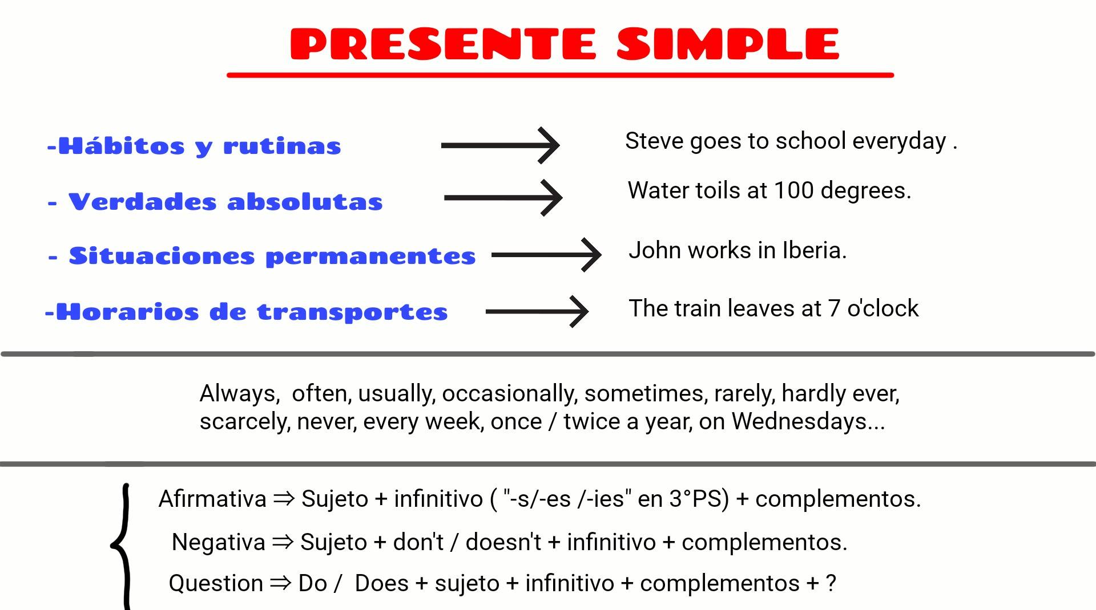
Examples:
Affirmative form:
- I go to the supermarket every day.
- Mary plays the guitar once a week
Negative form:
- I don’t go to the supermarket every day.
- Mary doesn’t play the guitar once a week
Question form:
- Do you go to the supermarket?
- Does she play the guitar?

Activities
1. Underline the verbs.
a. Katie has an important math test on Friday.
b. What things do you like todo to relax?
c. She feels annoyed because her friend Paulina tells her to date her brother.
d. Katie is afraid because the math test is only one day away.
e. Paulina and Katie are friends again after Paulina tells Katie that she is sorry.
f. How does Katie feel today?

2. Read the paragraph about Paul’s routine. Underline the affirmative statements and circle the negative sentences.
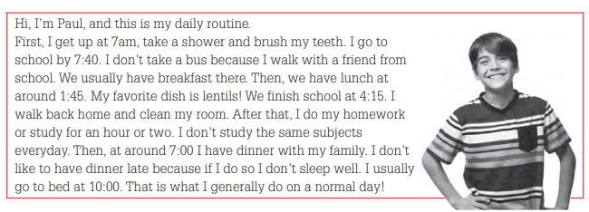
- Write the verbs in the correct form to complete the sentences.
a. Samantha _____________ football with her friends every Sunday.
(play/ plays)
b. Martin _____________________ lunch at home.
(don’t have /doesn’t have)
c. I _________________ tired this week. I think I will rest during the weekend.
(feel / feels)
d. Do you ________________ any good restaurants around town?
(know/ Knows)
e. That plan _________________________ very good. I __________________ to stay home.
(don’t sound/ doesn’t sound) (prefer/prefers)
f. I ____________________ fish, or meat. Remember that I’m a vegeterian.
(don’t eat/ doesn’t eat)

- Write about your habits or routines. Remember to use the present simple tense.

______________________________________________________________________________________________________________________________________________________________________________
- Read the dialogue. Pay attention who is giving information and who is asking for information.
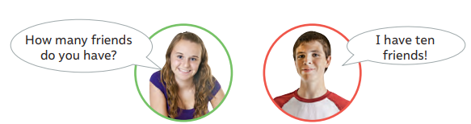
- Match the questions with the answers.
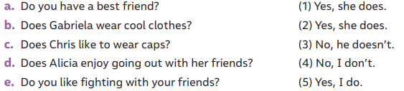
- Complete the following rules with DON’T or DOESN’T.
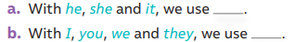
- Use the words provided in the word bank to complete the sentences.
                     

