
Nuestra misión: “ Formar hombres y mujeres Cristianos , Nobles y Capaces ”

Curso: Octavo Básico

Asignatura: Inglés

Clase: 3 Expressing Possessions and Expressing Preferences

Instructivo:
- Lee con atención en el contenido donde se explica el uso de los pronombres posesivos y cómo usar correctamente los verbos que indican preferencia.
- Desarrolla las actividades que siguen finalizada la explicación del contenido. Puedes imprimirla o desarrollarla en tu cuaderno de inglés.
- Luego, envía una foto/ imagen de las actividades finalizadas al e-mail hruiz@colegionuevanazaret.cl Indicando nombre del alumno y curso.
- Fecha de entrega: 12 de mayo 2020 hasta las 22:00 horas.

Contenido:
- Expressing Possesions

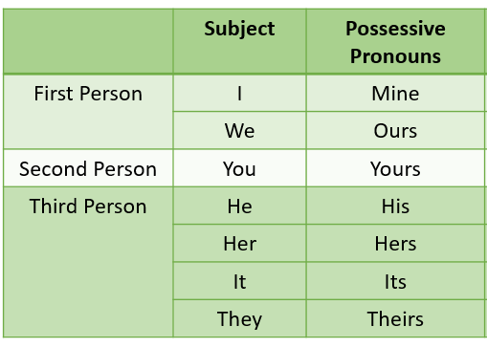
In English, one way of expressing possession is to use possessie pronouns like: MINE, YOURS, HIS, HERS, OURS, THEIRS.
Examples:

- This pencil is mine. (este lápiz es mio)
- The flowers are yours. (las flores son tuyas)
- This is not my bag. It’s his. (este no es mi bolso. Es suyo (de él))

Look at the pictures below paying attention to the words in bold.

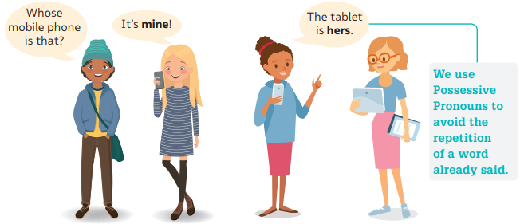

- Expressing Preferences
Preferences:
The verbs like, enjoy, love and dislike, don’t mind, hate, etc., are used to express preferences.

Grammar
These verbs are usually followed by a gerund (verb –ing). Look at the examples:

Form: Subject + preference + verb –ing + complement

Examples:
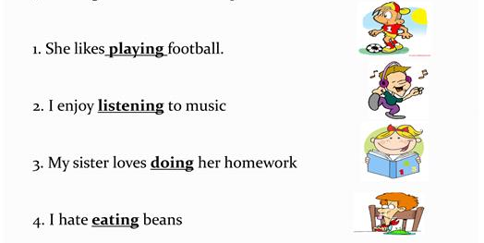

Actividades
1) Complete the sentences with the correct possessive pronoun. (mine, your, his, hers, ours, theirs)
a. Fabián has a new computer. I think the one on the desk is__________
b. My app doesn’t work. Can I use _________?
c. We paid for that program. It is ___________
d. Sofía left the tablet in the classroom. So this tablet is not _____________
e. I can help you with the project. If your computer is old, use ___________
f. My classmates created a website. Your idea looks very similar to ____________
g. I have a new smartphone. The phone is _________
h. Last year, grandpa gave me and my sister a new gaming console. The console is ____________

- Read the sentences below, paying attention to the underlined verbs.
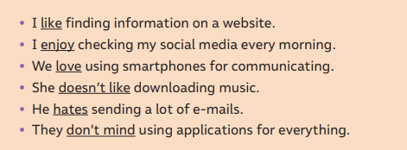
Answer in English:
a. What do these verbs express? __________________________________
b. What verb form goes after these verbs? ___________________________________
c. Which verbs have a positive meaning and which ones have a negative meaning?______________________________________________________________________________
3) Look at the graphic and use the expressions in it to create sentences saying how much you like doing the activities below.
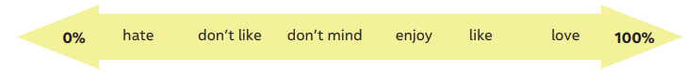
Example:

Stay at home: I don’t like staying at home but it’s important for our health__________________

b. Text messaging: ___________________________________________________________________
c. Posting on social media: _____________________________________________________________
d. Watching videos: __________________________________________________________________
e. Playing games: ____________________________________________________________________

