
Nuestra misión: “ Formar hombres y mujeres Cristianos , Nobles y Capaces ”

Curso: QUINTO BASICO
Asignatura: Inglés

Clase: 6 Writing
Instructivo:
- Ingresar a google classroom con el código 6dw5wgd Desde ésta aplicación también puedes aclarar dudas directamente con el profesor.
- Observa el Power Point sobre house and there is/there are.
- Desarrollar las actividades indicadas en contenido. Entregar el día lunes 15 de junio, hasta las 22:00 horas.
- Enviar la actividad finalizada al correo hruiz@colegionuevanazaret.cl. Si no puedes imprimir, desarrolla la tarea en tu cuaderno. Tómale una foto y envíala al email indicado.

Contenido:
- Name 10 objects in your house. Write in English and Spanish.
Example: table: mesa

1. | 6.
2. | 7.
3. | 8.
4. | 9.
5. | 10.

- Unscramble the words. Use a dictionary to help you.
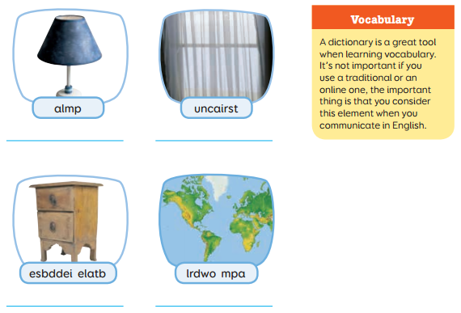

- Read the dialogue. Translate into Spanish.

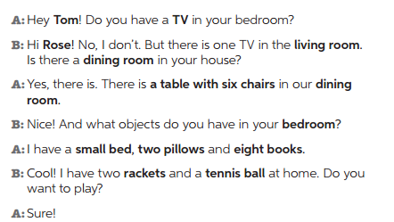

________________________________________________________________________________________________________________________________________________________________________________________________________________________________________________________________________________________________________________________________________________________________________________________________________________________________________________________________________________________________________________________________________________________________________________________________________________________________________________________________________________________________________________________________________________________________________________________________________________________________________________________________________________________________________________________________________________________________________

- Create a dialogue similar to the activity 3 using your own information for the words in bold. (crea un diálogo similar al de la actividad 3 usando tu propia información para las palabras ennegrecidas)

________________________________________________________________________________________________________________________________________________________________________________________________________________________________________________________________________________________________________________________________________________________________________________________________________________________________________________________________________________________________________________________________________________________________________________________________________________________________________________________________________________________________________________________________________________________________________________________________________________________________________________________________________________________________________________________________________________________________________
________________________________________________________________________________________________________________________________________________________________________________________________________________________________________________________________________________________________________________________

- Create a dialogue using IS or ARE.
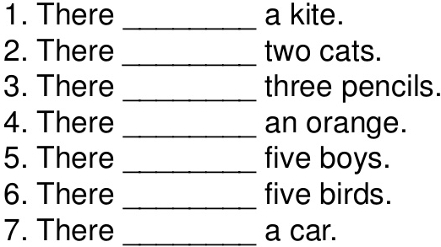

- Describe this pictures. Use there is and there are.
Example: there is a carpet in the living room (hay una alfombra en el living)
 | - __________________________  _____________________________  - _____________________________  ________________________________  - _____________________________  ________________________________

 | - __________________________  ____________________________  - ___________________________  ______________________________  - ___________________________  ______________________________

