
Nuestra misión: “ Formar hombres y mujeres Cristianos , Nobles y Capaces ”

Curso: Octavo Básico

Asignatura: Inglés

Clase: 7 “final assessment unit 2”

Instructivo:
- Ingresa a google classroom con el código p7ukyyc
- Observa el power point resumen de los contenidos de la unidad 2.
- Luego desarrolla las actividades indicadas en contenido.
- Finalmente, envía una foto/ imagen clara de las actividades finalizadas al e-mail hruiz@colegionuevanazaret.cl Indicando nombre del alumno y curso.

Contenido:
Actividades

- Match, and write the letter.

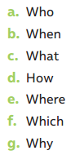 | __________  __________  __________  __________  __________  __________  __________ | 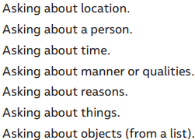

- Prepositions IN – ON – AT. Write the time expressions from the box below in the correct column.

- Write sentences using the correct verb “make or do” and the words in the box.

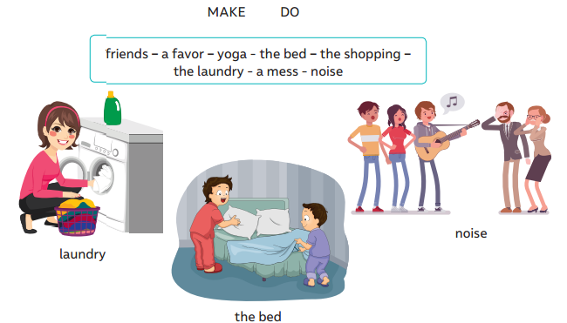
Example:

1.__I make friends___________________________  2._________________________________________  3._________________________________________  4._________________________________________ | 5._________________________________________  6._________________________________________  7._________________________________________  8._________________________________________
- Read the article and answer the questions.

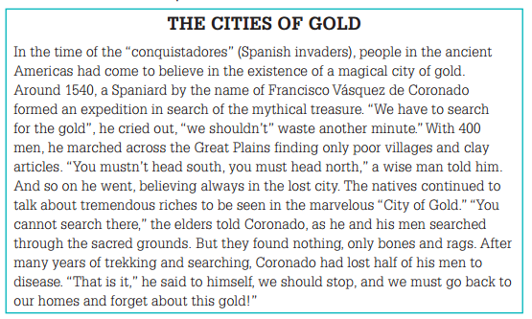

- Choose the nationalities from the box and write the correct one under each landmark. Be careful! There are three extra words.
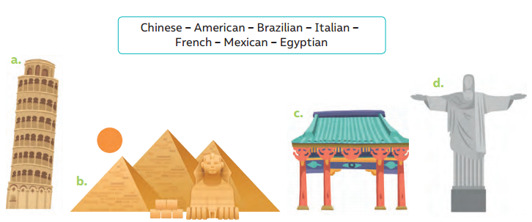
_______________ ____________________ __________________ ________________

- Complete the sentences using the correct form of the comparative.
Example:
USA is bigger than (big) China

- USA’s constitution is __________________________(old) Chile’s constitution.
- China is __________________________________ (populated) Germany.
- Chile is ___________________________________(small) Argentina.

- Complete the sentences using the correct form of the superlative.
Example:
China has the oldest (old) formation according to history

a. Chile is ___________________________________(long) country in the world.
b. China is __________________________________(populated) country in the world.
c. Brazil is __________________________________ (large) country in South America

