
Nuestra misión: “ Formar hombres y mujeres Cristianos , Nobles y Capaces ”

Curso: QUINTO BASICO
Asignatura: Inglés

Clase: 9 Unit 3: Let’s go shopping (listening)
Instructivo:
- Ingresar a google classroom con el código pefeoba
- Descarga el Power Point Let’s go shopping (tiene audio incluido)
- Desarrollar las actividades indicadas en contenido. Si no puedes imprimir y tampoco realizarla en el mismo documento. ESCRIBE LAS RESPUESTAS en tu cuaderno.
- Enviar la actividad finalizada al correo hruiz@colegionuevanazaret.cl. Tómale una foto y envíala al email indicado.
- Puedes usar tu cuadernillo de trabajo para complementar los contenidos página 20 y 21.

Contenido:
- Listen to the song and complete. (Escucha la canción y completa) (track 25)

Mum (x4) - boots - baker’s – bus – buy - shops – choose - greengrocer’s – supermarket –sport - clothes
We’re going shopping, ___________ and I
For all the things we need to buy.
Get off the bus and look around,
At all the ____________ in our town.
A _______________ and a _______________ too
A ______________________ with food for you.

We’re going shopping, ___________ and I
For all the things we need to buy.
If you need ____________ or books or shoes,
There’s lots of shops for you to choose.
If you need football __________ or shorts,
Then there’s a special shop for ____________.
We’re going shopping, ___________ and I
For all the things we need to buy.
And look! A new computer shop,
Just in front of our ___________ stop.
We’re going shopping, Mum and I,
For all the things we need to ___________.
We’re going shopping, ___________ and I
For all the things we need to buy.

- Match the person to the correct shop. (Une a la persona con la tienda correcta) (track 32)

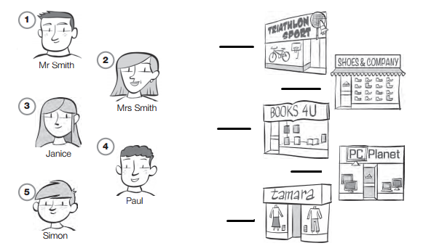

- Answer the question YES, I DO or NOT REALLY and add your preference. ( responde las preguntas con YES, I DO or NOT REALLY y agrega tu preferencia)

Example: DO YOU LIKE JOKE BOOKS? NOT REALLY. I HATE JOKE BOOKS, I PREFER COMIC BOOKS.
¿Te gustan los libros de chistes? No realmente. Yo detesto los libros de chistes. Yo prefiero los comics.

Do you like novels? ____________________________________________________________
Do you like fiction books? _______________________________________________________
Do you like reading? ___________________________________________________________
Do you like go shopping? _______________________________________________________

- Complete the dialogue. (completa el diálogo)
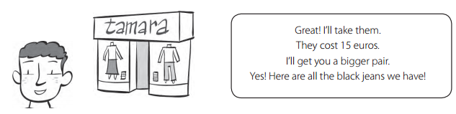
Paul: Have you got any black jeans?
Shop assistant: __________________________________________________________________________
Paul: I like these but they are too small!
Shop assistant:__________________________________________________________________________
Paul: These are perfect. How much are they?
Shop assistant:__________________________________________________________________________
Paul: __________________________________________________________________________________

