
Nuestra misión: “ Formar hombres y mujeres Cristianos , Nobles y Capaces ”

Curso: Séptimo Básico
Asignatura: Inglés

Clase: 8 Unit 3: Sports and free-time activities

Instructivo:
- Ingresa a google classroom con el código 5mjrli7
- Descargar el power point “Sports”
- Desarrolla las actividades asignadas en contenido. Usando el power point.
- Luego envía tus actividades finalizadas al e-mail hruiz@colegionuevanazaret.cl Indicando nombre del alumno y curso.
- Si tienes el cuadernillo del estudiante, puedes desarrollar las actividades de la pág. 36 y 37.

Contenido:

Actividades

- In the power point. Read the text “Olympic Heroes in Greece” and answer the questions.
a. What sport did they play? ______________________________________________________________
b. What is the title of the text about? _______________________________________________________
c. Why is this considered a historical event? __________________________________________________

2. Read the text quickly, and then choose the correct option.
a. This happened in the city of Patras / Athens / Rome.
b. Fernando González suffered a leg / hand / ankle injury.
c. Nicolás Massú played the finals against Tyler Dent / Mardy Fish /Fernando González.

3. Read the text again and decide if the following sentences are True or False.
a. This was the first time Chile won an Olympic medal. T/F
b. Both tennis players faced the same opponent in the tournament. T/F
c. After his injury, González lost and did not keep playing in the Olympics. T/F
d. The Chilean duo lost the doubles finals. T/F
e. Nicolás Massú is a double gold medalist. T/F

4. After Reading. Number the correct order of the events (1 to 5)
______ Chile wins its first gold medal in history.
______Fernando González gets injured.
______ Fernando González beats Tyler Dent.
______ Mardy Fish loses to Nicolás Massú.
______The Chilean team wins gold in the men’s finals.
5. Reading and Vocabulary. Look at the following words and circle only those that you found in the text or that can be used when talking about tennis. THERE ARE 7 WORDS
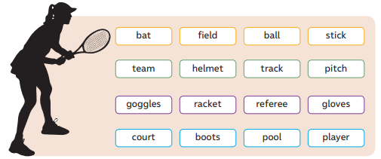
6. Write which of the words from activity 5 matches the following definitions.
a. An official who watches the action in sports closely to make sure that the rules are being followed and respected: R ___________ .
b. Something made out of wood that is used in certain sports to strike a ball: B__________.
c. Equipment that has been designed to protect the eyes: G___________________.
d. A round object that is typically used in many different games: B_____________.
e. A place that is usually related to sports, but can also be used for concerts and other important events: f________ .

7. Complete the following table by adding more sports or physical activities that go with the verbs.
Tennis, ... | Gymnastic,... | Climbing,…

8. Answer the following questions.
a. Which of the sports that you listed on activity 7 is something that you have always wanted to try?
_______________________________________________
b. Is there a sport that you listed to in activity 7 that you would never play or do? ________________

