
Nuestra misión: “ Formar hombres y mujeres Cristianos , Nobles y Capaces ”

Curso: Octavo Básico

Asignatura: Inglés

Clase: 8 unit 3:
Instructivo:
- Ingresa a google classroom con el código 233qqtj
- Observa el power point de la unidad 3.
- Luego desarrolla las actividades indicadas en contenido.
- Finalmente, envía una foto/ imagen clara de las actividades finalizadas al e-mail hruiz@colegionuevanazaret.cl Indicando nombre del alumno y curso.

Contenido: Actividades

- Listen and complete the song.
think – went – left – swam – friends – Perú – mountain – England - timid– places – saw

I’ve been around the world, I’m not a _____________ girl.
What do you ___________ of that? I’ve learned some languages,
bought stuff in Selfridges,
and a fancy hat!
(Chorus)
What can I tell you that you don’t know about the ___________
I’ve been?
Got lots of photos and some videos to show,
of the things I’ve seen.
Last year I ___________to Rome,
I ____________ my ___________ home.
Danced in a Spanish park.
I ____________ a coral reef,
I snorkeled, ______________ and skied,
I even met a shark!
(Chorus)
Next time you’ll come with me,
In ___________ we’ll drink tea.
I can show you around
In Chile and ____________,
I’ll introduce you to
all of the ______________ I’ve found.
(Chorus)
Of the places I’ve been,
of the things I’ve seen.

- Listen to the song and write the countries and cities that are mentioned. (track 13)
CITIES: ___________________
COUNTRIES: _____________________________
3. Listen to the song again and answer the following questions.
a. What things did the traveler do in the past? ______________________________________________
b. What will the traveler do in the future? __________________________________________________
c. What other experiences does the traveler mention?________________________________________
4. After Listening. Answer the following questions.
a. Where did you travel on your last vacation?________________________________________________
b. What did you do?_____________________________________________________________________
c. Where would you like to go in the future?__________________________________________________
5. Read the sentences below and number them in the correct order (1 to 4) to create a paragraph about a daily routine.
a. Next I brush my teeth and say goodbye to my family. _______
b. Finally I go out and wait for the bus to get to school. _______
c. Every day I wake up at 7 a.m. First I take a shower and get dressed. _______
d. Then I have breakfast while I watch the weather forecast. _______

6. Read the text and underline the correct connector. 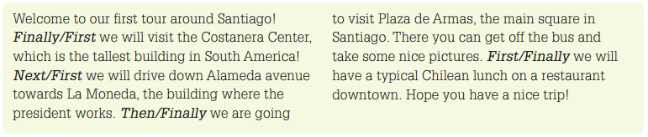
7. Match the words below to the pictures.

   

