
Nuestra misión: “ Formar hombres y mujeres Cristianos , Nobles y Capaces ”

Curso: SEXTO BASICO NAME: ___________________
Asignatura: Inglés GRADE: __________________

Clase 9: Adverbs of manner

Instructivo:
- Ingresa a google classroom con el código 2zelobg
- Primero debes ver el power point “Adverb of manner”.
- Luego, desarrollar las actividades indicadas en contenido. Si no puedes imprimir y tampoco realizarla en el mismo documento. ESCRIBE LAS RESPUESTAS en tu cuaderno.
- Enviar la actividad finalizada al correo hruiz@colegionuevanazaret.cl. Tómale una foto y envíala al email indicado.

Contenido:

- Underline the habitats and actions you can find. (subrayas los hábitats y acciones que encuentres) (10 points)
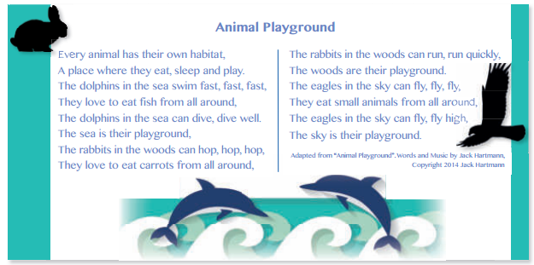

Actions | Habitat
1. | 1.
2. | 2.
3. | 3.
4.
5.
6.
7.
- Look at the pictures and complete the sentences using the words in the box. (Mira las imágenes y completa las oraciones usando las palabras de la caja) (6 points)

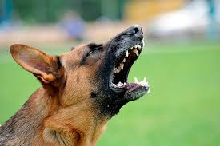 a. Some dogs can bark really ___________________.
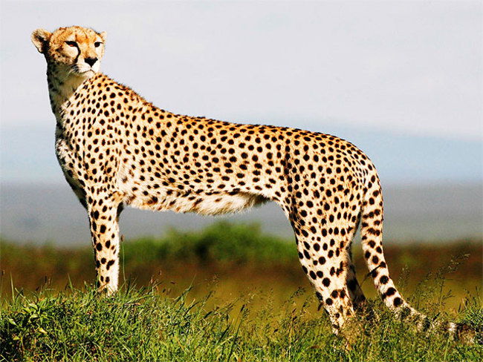 b. My favorite animal is the cheetah because it can run very_________.
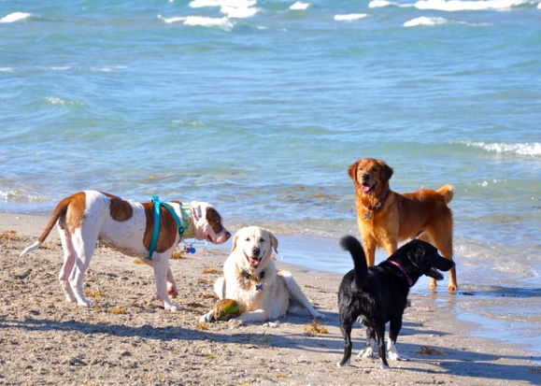 C. My dogs play _____________ together in the beach.
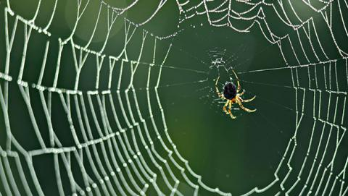 D. Spiders weave their nets very ______________ .
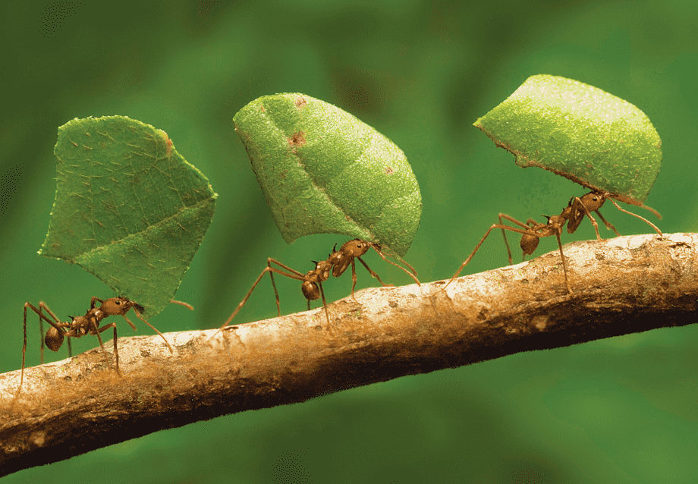 E. Ants work ________to prepare for the winter.
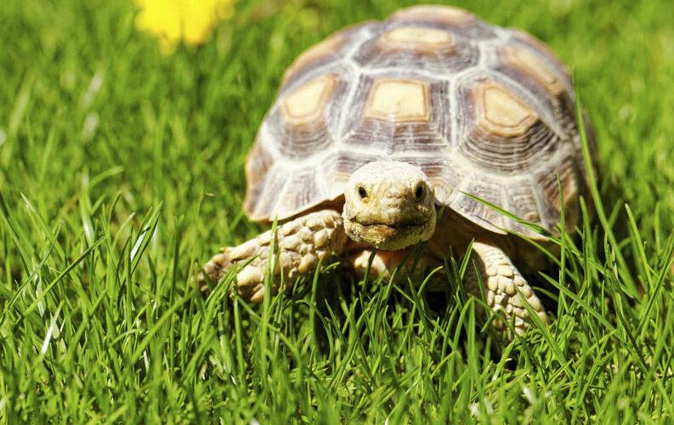 F. I like turtles because they walk_____________ .

- Choose the correct word to complete the sentences. Use adverbs of manner. (escoge la palabra correcta para completar las oraciones. Usa adverbios de manera) (8 points)

1. | She was late so she had to dress quick / quicker / quickly.
2. | The hero hit the crocodile hard / hardly / hardily on its nose, and escaped.
3. | You play the piano beautiful / beautifully / beauty.
4. | George stood up and walked slow /slowly /slower out of the room.
5. | I did bad / badly / worse in my exams. I’m sure I will have to repeat a year.
6. | They ran fast / fastily /fastly but they couldn’t catch the criminal.
7. | He drives danger / dangerously / dangerous. One day he will have an accident.
8. | She has painted her room really good / goodly / well. It looks brilliant!
- Read the text and complete the chart. (Lee el texto y completa el recuadro) (3 points)
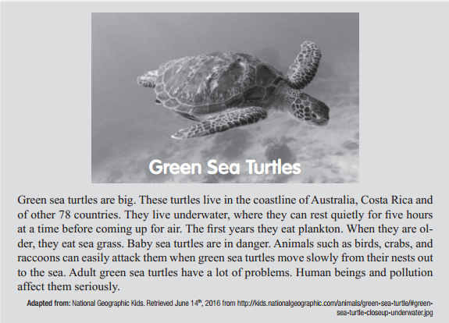




- Write sentences describing your favorite animal. Mention its habitats, diet and personality characteristics. (Escribe oraciones describiendo tu animal favorite. Menciona su habitat, dieta y características personales) (5 points)



