
Nuestra misión: “ Formar hombres y mujeres Cristianos , Nobles y Capaces ”

Curso: Séptimo Básico NAME: ______________________
Asignatura: Inglés GRADE:_____________________

Clase: 9 - SIMPLE PAST

Instructivo:
- Ingresa a google classroom con el código 5mjrli7
- Descargar el power point about “simple past” + la lista de verbos irregulares
- Desarrolla las actividades asignadas en contenido. Usando el power point si es necesario.
- Luego envía tus actividades finalizadas al e-mail hruiz@colegionuevanazaret.cl Indicando nombre del alumno y curso.
- Si tienes el cuadernillo del estudiante, puedes desarrollar las actividades de la pág. 36 y 37.

Contenido:

Actividades
- Look at the word and write if the verbs is regular or irregular in the past tense. (8 pts.)
Danced ___________________
Swam ____________________
Cried ____________________
Played ___________________
Went ____________________
Read ____________________
Finished __________________
Met _____________________

- Write these verbs in their past form. Use the clues to solve. (8 pts.)
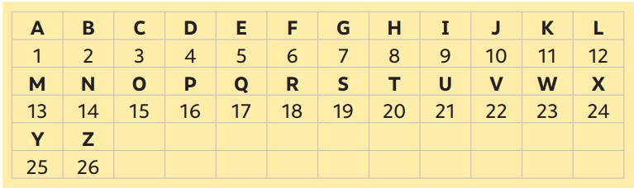

2. Read the sentences and complete them with the missing verb. Use some of the verbs from the last exercise. (3 pts.)
a. Nicolás Massú and Fernando González _______________an Olympic gold medal.
b. They _____________ in the first chilean couple of tennis players in obtain that kind of prize.
c. Fernando González _________________ playing after suffering an ankle injury during the match.

3. Transform these sentences into the past simple tense. Change the verb. (6 pts.)
a. I am very good at playing tennis. I keep working in my aces.
__________________________________________________________________________
b. Sam works hard everyday to obtain his veterinarian degree.
_________________________________________________________________________
c. It becomes very easy when you explain the subject.
_________________________________________________________________________
d. My parents study psychology with Dr. Anderson.
_________________________________________________________________________
e. Raphael and you keep living in Osorno.
__________________________________________________________________________
4. Write in the past form of the verb. (Escribe en la forma pasada del verbo) (20 pts.)
1.watch - ………………………………… 2.stop-……………………………………
3.play-…………………………………….. 4.study-…………………………………
5.live-……………………………………… 6.visit-……………………………………
7.be-……………………………………….. 8.buy-……………………………………
9.cost-…………………………………….. 10.drink-………………………………
11.drive-…………………………………. 12.have-………………………………..
13.make-……………………………….. 14.write-………………………………..
15.read-………………………………… 16.catch-……………………………….
17.spend-………………………………. 18.run-…………………………………..
19.lose-………………………………….. 20.swim-………………………………..

