
Nuestra misión: “ Formar hombres y mujeres Cristianos , Nobles y Capaces ”

Curso: Octavo Básico NAME:____________________________
Asignatura: Inglés GRADE:___________________________

Clase: 9 – Reading and Writing about travel
Instructivo:
- Ingresa a google classroom con el código 233qqtj
- Observa el power point
- Luego desarrolla las actividades indicadas en contenido.
- Finalmente, envía una foto/ imagen clara de las actividades finalizadas al e-mail hruiz@colegionuevanazaret.cl Indicando nombre del alumno y curso.

Contenido: Actividades

- Read the text “A Travel Itinerary” and answer the questions. (11 points)

- What is a travel itinerary?

- Why is it important for travelers?

- Vocabulary:

Travel: | Budget: | Weather:
Trip: | Accommodation: | Afford:
Abroad: | Flights: | See:

- Read the text “A Travel Itinerary” again and circle the items that are mentioned below. (4 points)
- Plan your next vacation using the tips from the text. Complete the following table with your own itinerary. (7 points)
Location | Start Date | End Date | Things to do | Essentials | Transportation

- Read the following postcard and pay attention to the content.
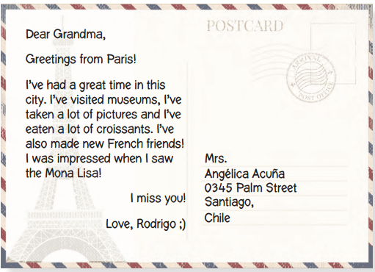
- Write a postcard about a trip you’ve gone on recently. If you haven’t traveled yet, imagine your dream holiday and include the information of the place you would like to visit. Don’t forget to choose the recipient of your postcard. (10 points)

