
Nuestra misión: “ Formar hombres y mujeres Cristianos , Nobles y Capaces ”

Curso: Séptimo Básico NAME:_________________________
Asignatura: Inglés GRADE:________________________

Clase: 10 Reading an article and writing about sport.

Instructivo:
- Ingresa a google classroom con el código 46yicq5
- Descargar el power point
- Desarrolla las actividades asignadas en contenido. Usando el power point.
- Luego envía tus actividades finalizadas al e-mail hruiz@colegionuevanazaret.cl Indicando nombre del alumno y curso.

Contenido:

Actividades

- Read the article.
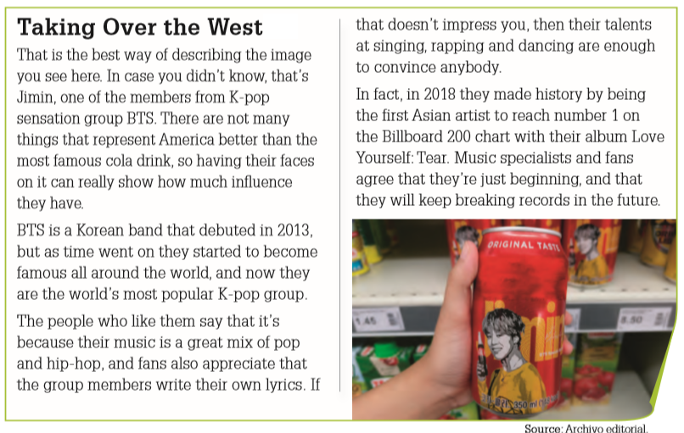
- Answer these questions. (responde las preguntas)
- Why do people like K-pop?
- Why is it important that K-pop artists appear on cans of the most famous cola drink?
- How did they make history in 2018?

- Unscramble the sentences. Use the correct punctuation when rewriting the sentences. (Utilice la puntuación correcta al reescribir las oraciones)

- K-pop group / really likes BTS / they are her favorite / my friend Francisca
_______________________________________________________________________________
- but she admits that they / listen to BTS / sing and dance really well / Karla doesn’t really
_______________________________________________________________________________
- I asked / and she said yes / my friend Paulina / do you like BTS
________________________________________________________________________________
- but he prefers other bands / he likes BTS / Esteban said that / like Twenty One Pilots
________________________________________________________________________________

- Answer the following questions. (responde las siguientes preguntas. En inglés)
a. Do you like or dislike K-pop? Why? _____________________________________________________
b. Why is K-pop different from the pop music from other countries? ____________________________

- Choose a sport, you have to keep in mind some of its most important details: name of sport, number of players, rules, places where the sport is popular, famous players, and more. Add pictures. (Elige un deporte, debes tener en cuenta algunos de sus detalles más importantes: nombre del deporte, número de jugadores, reglas, lugares donde el deporte es popular, jugadores famosos, y más. Agrega imágenes)

