
Nuestra misión: “ Formar hombres y mujeres Cristianos , Nobles y Capaces ”

Curso: Octavo Básico NAME:____________________________
Asignatura: Inglés GRADE:___________________________

Clase: 10 – Reading and Writing
Instructivo:
- Ingresa a un nuevo google classroom con el códigohven5ex Solo puedes ingresar con tu correo institucional.
- Observa el power point.
- Luego desarrolla las actividades indicadas en contenido.
- Finalmente, envía una foto/ imagen clara de las actividades finalizadas al e-mail hruiz@colegionuevanazaret.cl Indicando nombre del alumno y curso.

Contenido: Actividades

- Read the text “Getting Around Santiago de Chile” and answer the questions. (4 Points)
a. How can you get around Santiago?
b. If you like art, where should you go?
c. Where can you get a panoramic and impressive view of the city?
d. What is the best means of transportation if you want to get some exercise?
2. Vocabulary. Read the text again and match the means of transportation in the first column below with the corresponding definition. (4 points)

SUBWAY | ____ A vehicle pulled along a track by a cable, as up a steep hill.
CABLE CAR | ____A paid system that provides access to bicycles for a certain period of time.
BUS | ____An underground electric railroad.
BIKE SHARE | ____A large, long motor vehicle equipped with seating for passengers.

- Asking and giving directions. Read the table and write a dialogue between A and B. (5 points)
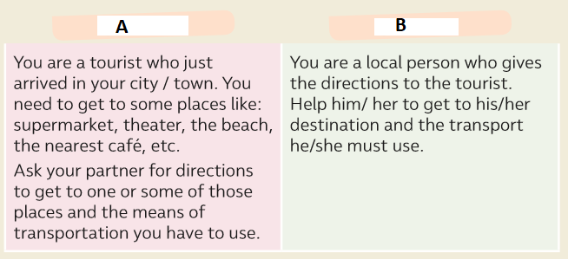

- Match the sentences below with their corresponding responses. (5 points)
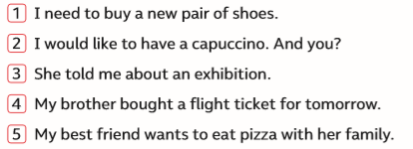
- _________ She is going to see a lot of paintings.
- _________ What time is he going to the airport?
- _________ Are you going to buy them in the department store?
- _________ They are going to eat in a restaurant called Napolitano.
- _________ I am going to take you to the best café.

- Number the conversation in the correct order. (8 points)
________A: Excuse me, how can I get to the subway station from here?
________B: No problem.
________B: You need to take the bus down Parkway.
________A: What number is it?
________B: Yes, it’s next to the bank.
________A: Great. Thanks.
________B: It’s bus number 9. You need to get off in front of the bank.
________A: Ok got it! Is the subway station right there?

- Write the name of the means of transportation under each picture. (4 points)


 
 

