
Nuestra misión: “ Formar hombres y mujeres Cristianos , Nobles y Capaces ”

Curso: QUINTO BASICO NAME:_______________________________
Asignatura: Inglés GRADE:______________________________

Guía 11
Instructivo:
- Ingresar a google classroom con tu cuenta institucional con el código todxniy para estudiar el power point trabajado en clases.
- Enviar la actividad finalizada al correo hruiz@colegionuevanazaret.cl. Fecha máxima de entrega 16 noviembre.
- Link de las clases online:
Martes 03 de noviembre: 5°B 10:00: https://meet.google.com/ysu-gwax-mhy
Martes 03 de noviembre: 5°A 12:00 https://meet.google.com/zcn-sjgx-pct
Martes 10 de noviembre: 5°B 10:00: https://meet.google.com/sjc-scrr-hht
Martes 10 de noviembre: 5°A 12:00: https://meet.google.com/kza-msgs-jps

Contenido:
- Look and write the words. (8 points)

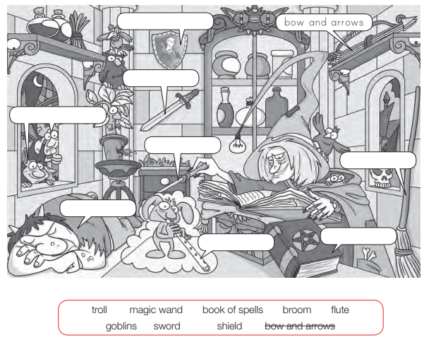

- Circle or underline the correct answer. (8 points)
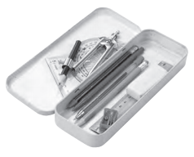
1. How many pencils are there / is there in the pencil case?
2. There is / There are a telephone on the table.
3. There isn’t / There aren’t enough orange juice for everyone.
4. Are there / Is there any boys in the classroom?
5. How many games is there / are there on your computer?
6. There is / There are a television in my bedroom.
7. There is / There are some shoes under the bed.
8. There isn’t / There aren’t any good programmes on TV tonight.

- Complete the table. (10 points)

Positive (+) | Negative (-) | Question (?)
There are 9 students in class.
 | There aren’t any apples.
 |  | Are there any exercises on the page?
There is a pencil on my desk.
 | There isn’t any milk.

- Answer the questions about your town. Use Yes, there is/there are or No, there isn’t/there aren’t. (5 points)

1. Is there a cinema in your town?__________________

2. Is there a park in your town? ____________________

3. Is there a skate park? _____________________

4. Is there a sports centre in your town? ___________________

- Are there tennis courts in the sports centre? _______________

5.Write 2 sentences with “There is” and 2 sentences with “There are” (4 points)

- ____________________________________________________________________________________________
- ____________________________________________________________________________________________

- ____________________________________________________________________________________________
- ____________________________________________________________________________________________

