
Nuestra misión: “ Formar hombres y mujeres Cristianos , Nobles y Capaces ”

Curso: Séptimo Básico NAME:_________________________
Asignatura: Inglés GRADE:________________________

Clase: Unit 4: Green Issues

Instructivo:
- Ingresa a google classroom con el código 46yicq5 y descargar el power point del sobre el contenido.
- Desarrolla las actividades asignadas en contenido.
- Luego envía tus actividades finalizadas al e-mail hruiz@colegionuevanazaret.cl Indicando nombre del alumno y curso. Fecha de entrega: 16 de noviembre

Contenido:

Actividades

1. Look at the images. Then, relate them to the concepts and write below. (06 points)
Plastic – Industrial zone – Fertilizer – Smog – Asthma – Fossil fuel

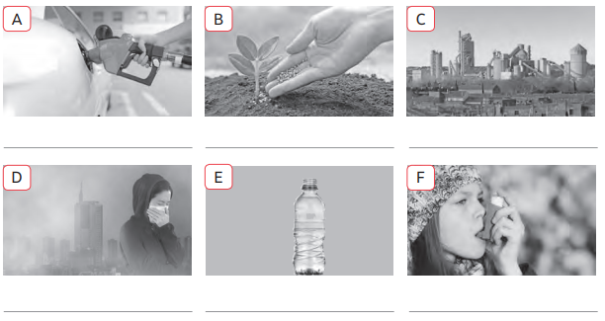
2. Use the words to complete the text. (10 points)

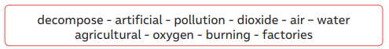

a. _______________________ happens when nature does not know how to b. ___________________an element that was not introduced in the environment naturally. If we put in the environment c._____________________ things like plastic, we pollute the environment. There are many types of pollution. First, there is d.____________________ pollution. Some of the main sources of this kind of pollution are the e. ______________________of fossil fuels and emissions of carbon f.______________
from vehicles and g.___________________ . Then, there’s h.________________ pollution.
Sources of this kind of pollution include the waste from i. ______________________fields, industrial sites and urban areas. Additionally, if fertilizers get thrown into the sea, algae grows too much, which reduces the amount of available j. ______________________ for other species.
3. Read the words in the chart. Complete blanks writing the kind of trash each container has inside. Color.

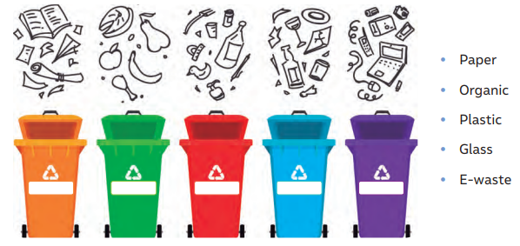

____________ - ________________ - _____________ - _____________- ______________

4. Answer the following questions. (3 points)
a. Is there any kind of pollution in your city? If so, what kind?___________________________________________________________________________
b. Do you do anything to fight against these types of pollution? What do you do?____________________________________________________________________________
c. How could you teach younger students in your school to protect the environment?____________________________________________________________________

5. Match the sentences with the same meaning. (9 points)
1.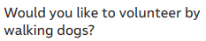 | _______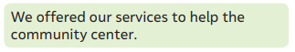
2.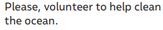 | _______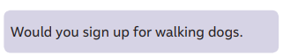
3.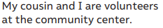 | _______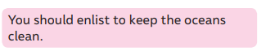
4.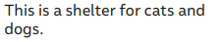 | _______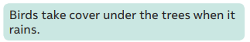
5.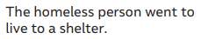 | _______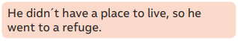
6.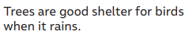 | _______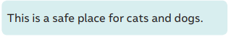
7.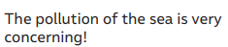 | _______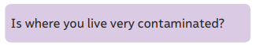
8.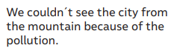 | _______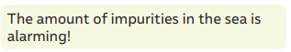
9.  

