
Nuestra misión: “ Formar hombres y mujeres Cristianos , Nobles y Capaces ”

Curso: Octavo Básico NAME:____________________________
Asignatura: Inglés GRADE:___________________________

Clase: 11 – Unit 4: future matters
Instructivo:
- Ingresa a un nuevo google classroom con el códigohven5ex Solo puedes ingresar con tu correo institucional.
- Revisar el power point para poder desarrollar la guía correctamente.
- Finalmente, envía una foto/ imagen clara de las actividades finalizadas al e-mail hruiz@colegionuevanazaret.cl Indicando nombre del alumno y curso. Fecha de entrega: 16 noviembre.

Contenido: Actividades

- Read the sentences and write them in the correct column below. (4 Points)
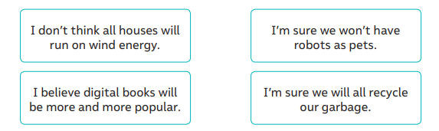
AGREEING | DISAGREEING
- Write your opinion in response to the statements below. Use the expressions from the box. (4 Points)

a. Robots will be common in homes and schools. __________________________________________
b. People will live on Mars by the year 2050. ______________________________________________
c. Next century, we will eat all of our food in the form of vitamin tablets. ___________________________________________________________________________________
d. Doctors will find a cure for cancer in the next ten years. ____________________________________
- Match the sentences with their meaning. (6 points)
a. E-kids | _____________ Sending messages on the Internet.
b. Multitasking | _____________ Connected to the Internet.
c. Online | _____________ To do many things at the same time.
d. Computer | _____________ Young people who use technology.
e. Texting | _____________ A device with a screen and a keyboard.
f. E-mail | _____________ To send a message by cell phone.
- Look at the photos from the future and complete the sentences with your own ideas. Use Will or Will not + verb in brackets. ( 8 points)
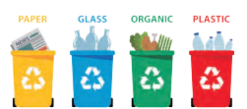 | a. Many people__________________ (recycle) in 2025.
 | b. Transportation _________________ (be) faster and cleaner.
 | c. Our houses ____________________ (only/use) renewable energy.
 | d. Global warming_____________________ (affect) glaciers.

- Match the sentences. (6 points)
a. There won’t be televisions in the future... | _________I will text you the address later.
b. I will buy a tablet... | _________if I have enough money
c. I’m sure you’ll like that cell phone... | _________I’m sure he won’t like this new cell phone.
d. Your computer is old… | _________because everyone will watch movies on their phones.
e. It’s great you’re coming to the party… | _________it has lots of applications
f. Mike’s a technophobe… | _________When are you going to buy a new one?

